**Test Document for Bug fixing - If drawing is expired its Items cannot be released**

Testing on Project - JB1052 and Element ID – 50500600

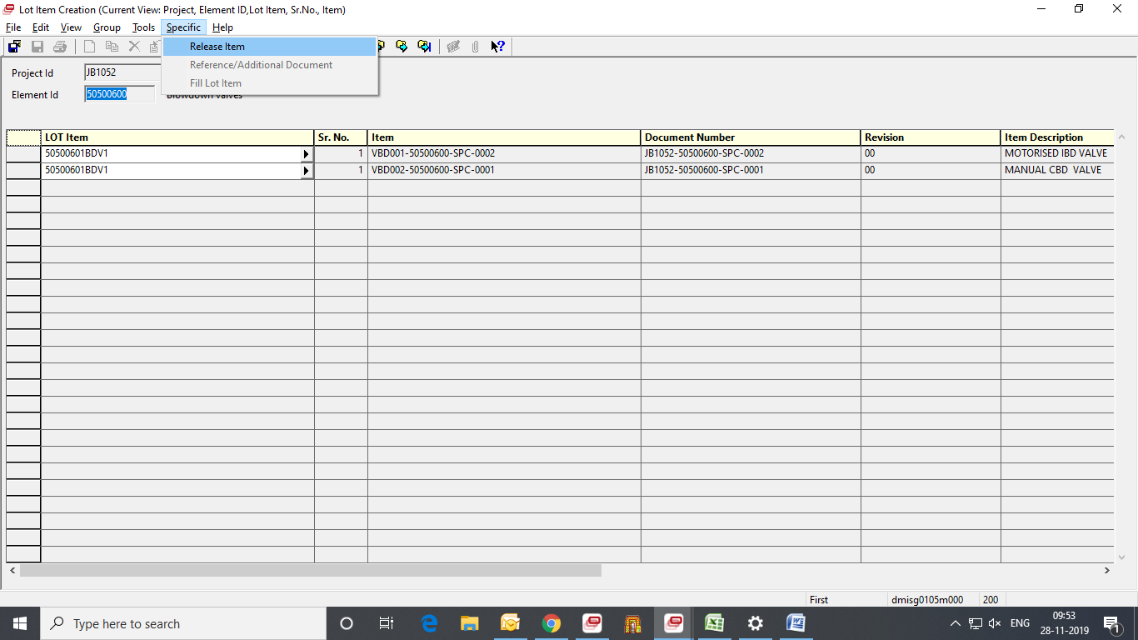

Document Status is expired, check by GTM.

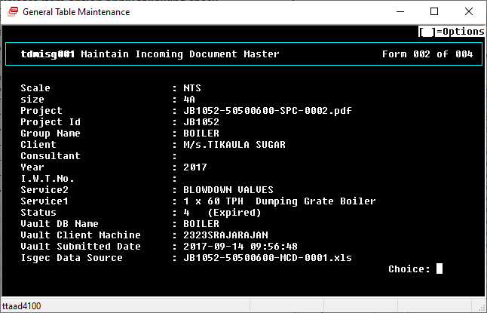

After Click Release Item Button, Error message occurs i.e.,

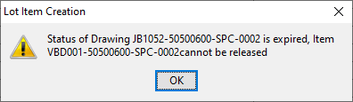

After changing the status of Document master from table dmisg001 in Drg Released, after that click Release Button.

